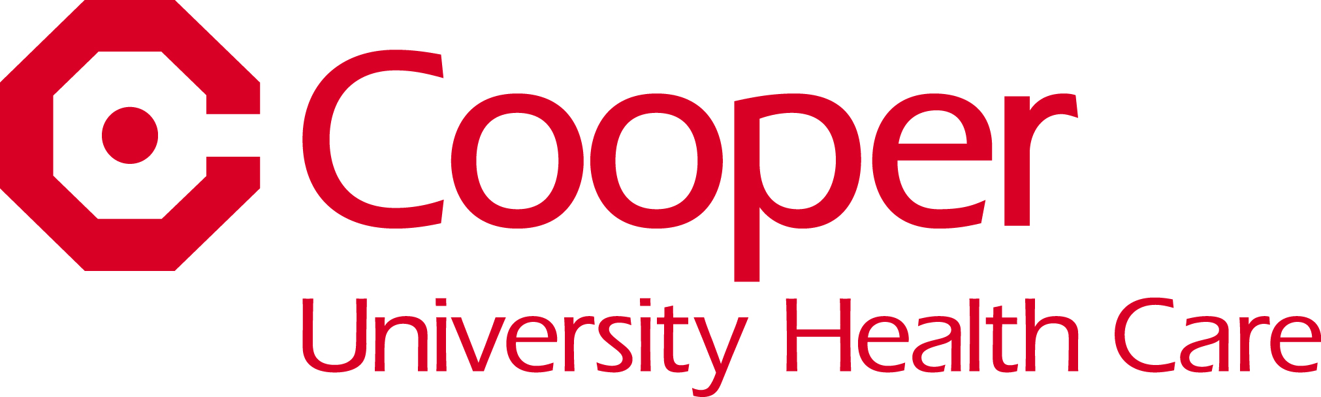

**The Cooper Health System – Continuing Medical Education**

**Cooper University Hospital MOCA® Simulation Course**

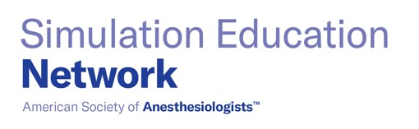

**FRIDAY, AUGUST 25, 2023**

**8:00 AM – 3:15 PM\***

**Joint Health Sciences Center**

**201 Broadway**

**Camden, NJ 08103**

**Course Director:**

Amanda R. Burden, MD

Director, Clinical Skills and Simulation

Cooper University Hospital

Professor of Anesthesiology

Cooper Medical School of Rowan University

Camden, NJ

The Cooper University Hospital Clinical Skills and Simulation Center offers leadership in the use of simulation technologies and is dedicated to advancing healthcare provider education and patient safety.

The Maintenance of Certification in Anesthesiology (MOCA®) Simulation course offers immersive simulation education endorsed by the American Society of Anesthesiologists (ASA) for ABA Diplomates seeking to fulfill their Part 4 Improvement Medical Practice (IMP) requirement for MOCA®. The simulation course fulfills one requirement of the ABA MOCA® Program.

Please consult the ABA website (www.theaba.org) for a list of all other MOCA® requirements. MOCA® and Maintenance of Certification in Anesthesiology Program are registered trademarks of The American Board of Anesthesiology, Inc.

***\*Course times are subject to change. All changes in class times/schedule will be sent to the participants by e-mail.***

**WHAT TO EXPECT IN A MOCA® COURSE**

Simulation-based learning embeds the lessons of the experience deeply into the participant without risk to patients.

**Course Objectives:**

1. Develop strategies to apply technical skills to appropriately diagnose and treat anesthesia emergencies.
2. Develop strategies to apply crisis resource management skills during clinical crisis situations.
3. Provide management of hemodynamic and respiratory critical events in anesthesia.
4. Practice up-to-date techniques in a safe, learning environment.
5. Reflect on optimal teamwork, leadership, and communication skills required in crisis management.
6. Develop strategies to apply reflective and self-assessment skills to review and analyze clinical performance.

**Course Highlights:**

1. Your performance will not be graded. THIS IS NOT A TEST!
2. Experiential learning: You will be in the “hot seat” as the primary anesthesiologist for at least one scenario.
3. Small class size with a participant to instructor ratio of 5:1.

**Intended Audience:**

The intended audience for this course is board certified anesthesiologists.

Cooper is a member of the American Society of Anesthesiologists’ (ASA) Simulation Education Network and is endorsed to provide MOCA® Simulation Courses that satisfy the simulation component of Part 4 MOCA®.

If you have any questions about course content or the course itself, please contact Amanda R. Burden, MD at burdena@rowan.edu.

**Cancellation Policy:** Registrant cancellations more than one month prior to the course date will receive a full refund minus a $250.00 processing fee. There will be no refunds for cancellations made within 30 days of the course. The Cooper Health System reserves the right to cancel this conference due to insufficient enrollment or other unforeseen circumstances.

**ACCREDITATION/DESIGNATION**

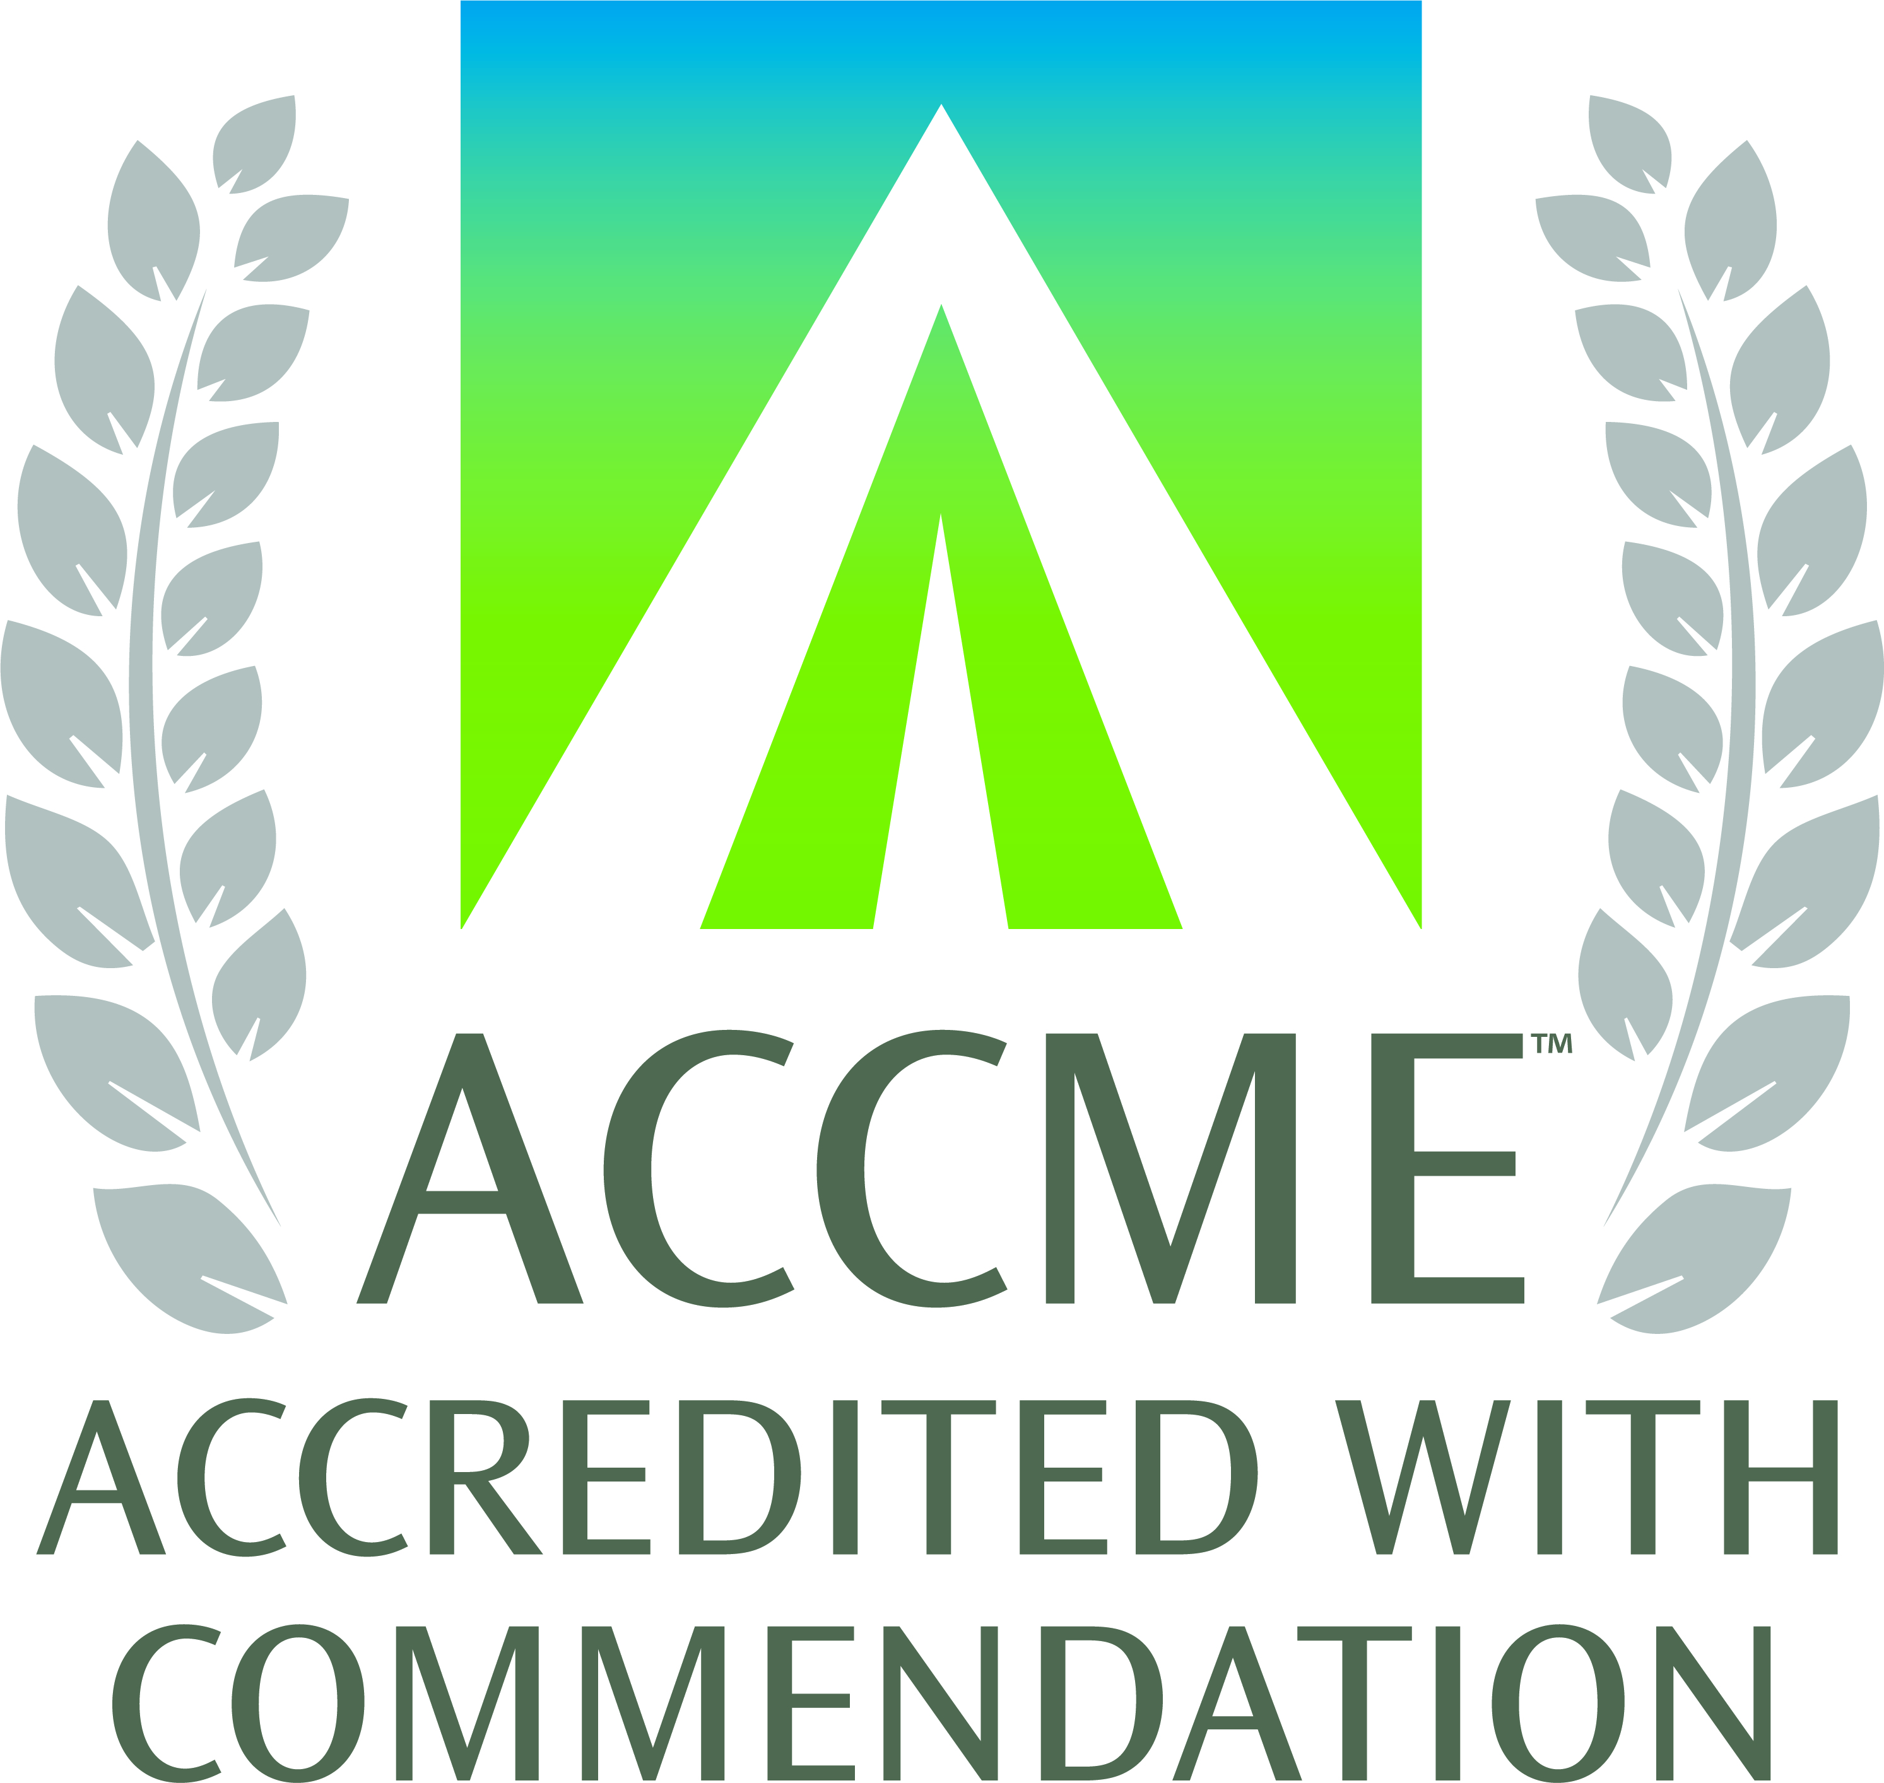

The Cooper Health System is accredited by the Accreditation Council for Continuing Medical Education to provide continuing medical education for physicians. The Cooper Health System takes responsibility for the content, quality, and scientific integrity of this CME activity.

The Cooper Health System designates this live activity for a maximum of **7 *AMA PRA Category 1 Credits™****.* Physicians should claim only the credit commensurate with the extent of their participation in the activity. This CME activity qualifies for 7 hours of patient safety CME.

**DISCLOSURE**

All planners, faculty, and others participating in continuing medical education activities sponsored by The Cooper Health System are expected to disclose all financial relationships.

All planners, faculty, and others for this CME activity have no relevant financial relationships with a commercial interest/ineligible company that may have an impact on this CME activity.

**Registration Information for Cooper University Hospital MOCA® Simulation Course**

**August 25, 2023**

If you have any questions regarding registration, please contact the Department of CME at (856) 382-6480.

Registration is required. Space is limited, so registrations will be accepted on a first-come, first-served basis. No registrations by telephone will be accepted.

**This MOCA®-accredited full-day course requires ABA board certification (or equivalent) as a prerequisite.**

**Mail registration and payment to:** Continuing Medical Education

The Cooper Health System

2nd Floor, Suite N-300

1 Federal Street

Camden, NJ 08103-1150

**Or e-mail ALL of the registration information requested below to:** [CME@cooperhealth.edu](mailto:CME@cooperhealth.edu)

**Or fax to: (**856) 382-6495

Faxed or e-mailed registrations accepted for credit card payments only.

**Conference Fee:** **$2,000.00** (includes breakfast and lunch).

**A notice will be sent to you to confirm your registration for the Cooper University Hospital MOCA® Simulation Course.**

**Method of Payment:**

My check for $ payable to The Cooper Health System is enclosed.

Please charge my:  American Express  MasterCard  Visa in the amount of $

Card Number Expiration Date

Name as it appears on the credit card

Authorized Signature

**Please print legibly.**

Name and Degree:

Address:

City/State/Zip:

Phone: Mobile Home or Work Fax:

E-mail (**required**):

Company Name:

City/State:

**\*\*ABA Number:**

**\*\*In order to complete your registration, you must include your ABA Number.**

□ If you require assistance with hearing, vision, or mobility to make this activity accessible to you, please check here and describe your needs below. Please provide this information by August 11, 2023. Please inform us of any dietary restrictions or food allergies. If we need more information, we will contact you prior to the event.